SERENİS HOTEL
2023 WINTER CONSEPT

Dear Guests,
Welcome at our Serenis Hotel. As Serenis Hotel family, we have already arranged everything to make your holiday as comfortable as possible. This guide will help You to use all the facilities and services. Enjoy your stay and have a marvelous holiday!

Food & Beverage Guide
RESTAURANTS AND FOOD SERVICE
Breakfast | 07:00 – 10:00 | Open Buffet | Main Restaurant
Late Breakfast | 10:00 – 10:30 | Open Buffet | Main Restaurant
Flatbread | 10:00 – 16:00 | Flatbread Service | Pool Bar
Snack | 12:00 – 15:30 | Open Buffet | Beach Bar
Snack | 12:00- -15:30 | Open Buffet | Pool Bar
Lunch | 12:30 – 14:00 | Open Buffet | Main Restaurant
Ice Cream | 15:00 – 16:00 | Ice Cream Service | Pool Bar
Coffee/Cake | 16:00 – 17:00 | Coffee/Cake Service | Pool Bar
Dinner | 18:45 – 20:45 | Open Buffet | Main Restaurant
Night Soup | 23:30 – 24:00 | Self Service | Main Restaurant
BARS
Lobby Bar | 10:00 – 24:00 | Local Alcoholic & Soft drinks | Lobby
Pool Bar | 10:00 – 24:00 | Local Alcoholic & Soft drinks | Pool Area
Beach Bar | 10:00 – 17:30 | Local Alcoholic & Soft drinks | Beach

- Management has the right to change the place and time of services.
- Our All Inclusive service consists of local alcohol and nonalcoholic beverages available from 10:00 till 24:00 without any charge.
- Imported drinks, champagne, special wines, bottle drinks and fresh pressed fruit juices are charged extra.
- According to Turkish laws it is not permitted to serve alcohol to children under 18 years old.
- Please don’t brink any food or beverage to the room from Restaurant
- Tea & coffee set in the Rooms.
- Shuttle Bus service (every 20 minutes).
- All kinds of beverages are served with glass. There is no bottle service available.

GENERAL INFORMATIONS

Minibar : Minibar is filled with soft drinks and updated daily
.
Wifi : Wifi at the lobby free, Hotel area and at the beach chargable

Safe : You can rent a safe box, which is located in your room, 1 € is charged per day. We kindly request you not to bring your valuables like handy, money,
etc. to the pool or seaside area. Hotel cannot be responsible for any loss.

Miniclub : The Mini club service is available for all children between 4-12 years old. For the further information please contact our Animation team.

Pool : The pools are chemically cleaned and tested between 20:00-06:00 hours. Jumping into the pool is dangerous

Towels : Please do not take the towels in your room outside, these towels are to be used only inside the room. Beach towels are offered by our hotel on free
basis, are at your service in the SPA center. In day 0,5 € is charged for second change of the beach towel. 10 Euro per each undelivered beach
towel card will be charged to your account in case of loss.

Arrival & : Check in time is 14:00 o`clock. To be able to prepare the room for our new guests, we kindly remind You to complete the c/out procedure and return
Departure the room card to the reception on the day of your departure before 12:00 o`clock. 10 € is charged in case of the card lose.

Free Activities Activities Charged Extra
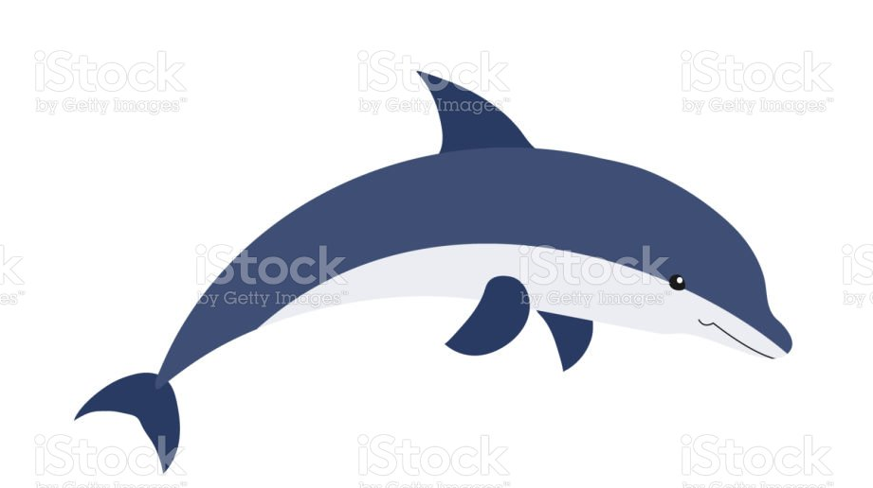
- Table Tennis - Sauna - Telephone - Biliard
- Turkish bath - Fitness Center (min.16 age) - Game Center - Water Sports (Private)
- Dart - Boccia - Doctor - Laundry Cervice
- Water Slides (10:00-12:00 // 14:00-16:00) - Massage - Fax

